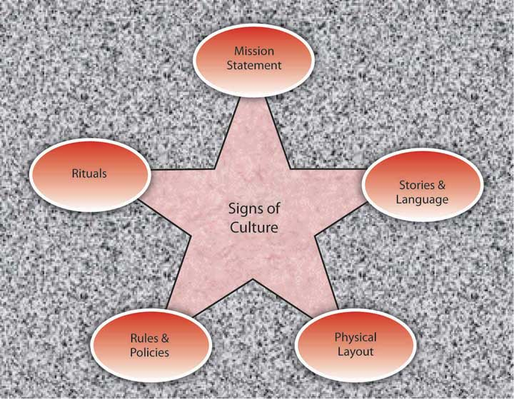

What are your school’s signs of culture?

The Organizational Culture Model
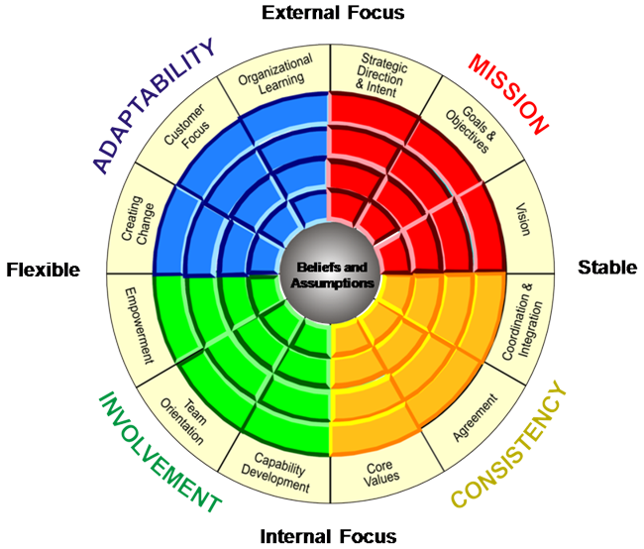

By Denison Consulting

Beliefs and assumptions drive an organization’s culture. Discuss your team’s beliefs and assumptions about each focus area.
Mission? (Intent of the organization)

Consistency? (Integration of initiatives)

Involvement? (Training and leadership)

Adaptability? (Change and new learning)

As we think about FULL IMPLEMENTATION of…
  - Standards Referenced Reporting
  - International Baccalaureate …During a Digital Transformation
  - Common Core State Standards

How will our team perform? Plan the performance culture of your team with the guidance of the graphic organizer below:
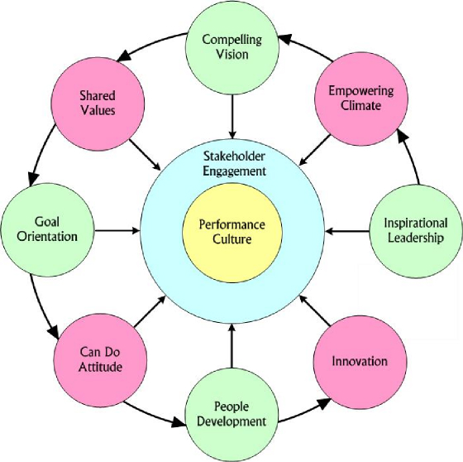
How will your leadership be inspirational?
How will your climate become empowering?
How will you make your vision compelling?
How will you develop shared values?
How will you keep your work goal oriented?
How will you develop a can do attitude?
How will you develop and grow your staff?
How will you become more innovative?

